Shriram AMC Expands Fixed Income Suite with Launch of Shriram Money Market Fund
- NFO will open on January 19, 2026, and close on January 21, 2026
- Open-ended debt scheme investing in money market instruments with residual maturity up to 1 year
- Relatively low-interest rate risk and moderate credit risk
- Aims to provide regular income with easy liquidity
- Scheme benchmarked against NIFTY Money Market Index A-I TRI
Mumbai, January 12, 2026: Shriram Asset Management Company Limited, part of the Shriram Group, has expanded its fixed income offering with the launch of the Shriram Money Market Fund, an open-ended debt scheme. The fund will invest in high-quality money market instruments with maturity of up to one year, aiming to provide regular income while maintaining high liquidity and a controlled risk profile, in line with regulatory norms.
Money market funds have increasingly emerged as a preferred option for investors looking to park short-term surplus funds, offering the potential for better returns than traditional savings instruments, along with daily liquidity and relatively low volatility. Reflecting this shift, money market fund AUM has grown more than threefold—from ₹1.11 lakh crore in the Oct–Dec 2022 quarter to ₹3.57 lakh crore as of November 2025 (as per AMFI)—as investors moved surplus funds into liquid, higher-yielding avenues amid higher interest rates and market volatility. Against this backdrop of rising demand for efficient cash management solutions, Shriram Asset Management Company Limited has launched the Shriram Money Market Fund, marking a strategic step in the expansion of its fixed income franchise.
As liquidity management becomes a core requirement for institutional treasuries, corporates and individual investors, the fund strengthens Shriram AMC’s offering beyond its existing debt products such as the Shriram Overnight Fund and Shriram Liquid Fund, while reinforcing the AMC’s intent to build a comprehensive and scalable fixed income bouquet aligned with evolving cash management needs.
Fund investment approach
Shriram Money Market Fund will invest in a diversified portfolio of money market instruments, as defined by SEBI and RBI from time to time, with residual maturity of up to one year. These instruments include Commercial Papers, Certificates of Deposit, Treasury Bills, Triparty Repo, Repo/ Reverse repo in government securities, Government securities with an unexpired maturity up to 1 year and any other short-term instruments allowed under current Regulations.
The scheme’s performance will be benchmarked against the NIFTY Money Market Index A-I (Total Return Index).
The launch also reflects Shriram AMC’s focused capability-building in fixed income. In October’25, the AMC strengthened its investment team with the appointment of Amit Modani as Senior Fund Manager and Lead Fixed Income, bringing extensive experience across money market and short-duration strategies. The Shriram Money Market Fund is the first new fund launch since his joining, underscoring the AMC’s ability to swiftly translate enhanced capabilities into product execution. Building on this momentum, Shriram AMC is actively expanding its fixed income product pipeline, with plans to introduce additional solutions aimed at meeting the evolving liquidity, duration, and risk management needs of institutional treasuries, corporates, HNIs, and retirees.
Mr. Kartik L Jain, MD & CEO, Shriram Asset Management Company Limited, said, “As liquidity management becomes a core component of portfolio construction across investor segments, we are strengthening our fixed income offerings to address evolving cash management needs. The launch of the Shriram Money Market Fund reflects this strategic focus, supported by the continued strengthening of our fund management capabilities, including the recent addition of Amit Modani to our fixed income team. With a clear emphasis on risk discipline and execution, we will continue to expand our fixed income product suite to offer relevant solutions across liquidity, duration and risk profiles.”
Mr. Amit Modani, Senior Fund Manager, Shriram AMC, added: “Our approach to managing the Money Market Fund is centred on high-quality instrument selection, prudent credit evaluation, and active liquidity management. By maintaining a well-diversified portfolio and closely monitoring market conditions, we aim to deliver risk-appropriate returns consistent with the fund’s objective. The scheme remains aligned with the core principles of money market investing — capital preservation, liquidity, and transparency.”
Investment Options
Investors can invest in Shriram Money Market Fund through lump-sum investments or Systematic Investment Plans (SIP). The minimum application amount is ₹1,000, and subsequent investments can be made in multiples of Re. 1 thereafter. There is no exit load with redemption proceeds expected to be dispatched within three business days, in line with regulatory norms. The scheme will be available under Direct and Regular Plans, with Growth option only. Investors can purchase and manage their investments online through the ShriFunds portal at https://shrifunds.shriramamc.in.
Shriram Group continues to strengthen its mutual fund business by expanding its range of relevant and differentiated investment solutions. With a focus on performance, product relevance, and distribution reach, Shriram AMC aims to address evolving investor needs across market cycles.
About Shriram Asset Management Company Limited
Shriram Asset Management Company Limited, part of the Shriram Group, was incorporated in 1994. The company received approval from SEBI to act as the Asset Management Company of Shriram Mutual Fund, vide registration no. MF/017/94/4. Shriram AMC offers a diversified mix of products comprising hybrid, equity, and debt funds so that customers can meet key goals and objectives. With a unique “quantamental” approach—blending the precision of quantitative analysis with the depth of fundamental research—Shriram AMC aims to help investors grow their wealth confidently and consistently. For more information, visit https://www.shriramamc.in/

Mutual Fund investments are subject to market risks, read all scheme-related documents carefully.

Media Contact information:
Smita Joshi: +919619044408
smita.j@shriram.com

Product Labelling and Riskometer

Shriram Money Market Fund
Fund Type: An open-ended debt scheme investing in money market instruments. A relatively low-interest rate risk and moderate credit risk

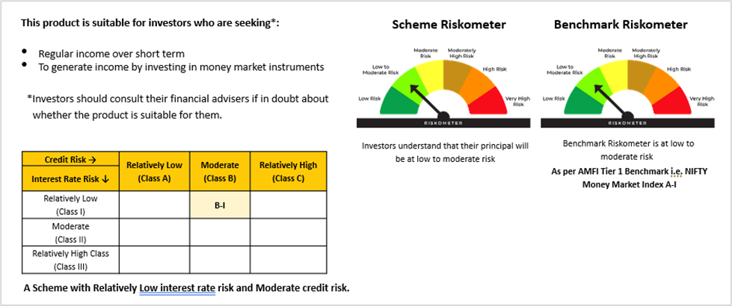

Disclaimer: Views expressed herein are for information purpose only. Please consult your financial advisor before taking investing decision.

The above product labelling assigned during the New Fund Offer (NFO) is based on an internal assessment of the scheme characteristics and the same may vary post NFO when the actual investments are made.

Shriram Overnight Fund
Fund type: An open ended debt scheme investing in overnight securities. A Relatively Low Interest Rate Risk and Relatively Low Credit Risk
Fund category: Debt Scheme. Riskometer: As on 31st December 2025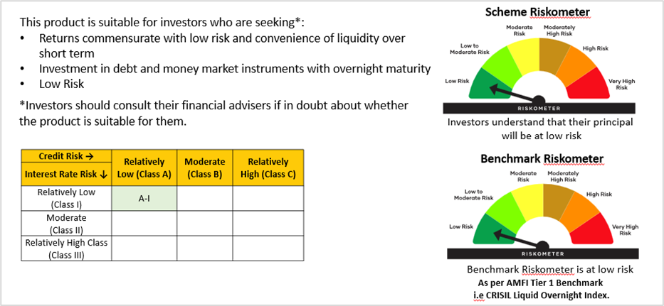

Shriram Liquid Fund
Fund type: An open-ended Liquid scheme. A relatively low interest rate risk and moderate credit risk
Fund category: Debt Scheme,
Riskometer: As on 31st December 2025
